**Treason Documentation**

**Created By**

Poom Suchao-in 6231349621

Napat Maneeratpongsuk 6231318121

**2110215 Programming Methodology Semester 2 Year 2020 Chulalongkorn University**

**Treason**

# Introduction

Treason is a game that inspired by contra, run and gun video game. The objective of the treason game is to win the enemy along the game and defeat the final boss at the end.

# Rules

You must use all yours weapon to fight along the incoming enemy with your limit health. If your health is zero or your character fells off the map the game is over. It will be a helping item that can give you some assisting. at the very end if you can defeat the final boss, then you win the game.

## Example

- your main character will start at the left of the map. You can move your main character by pressed W to jump, A to move left, D to move right and pressed SPACEBAR to attack.

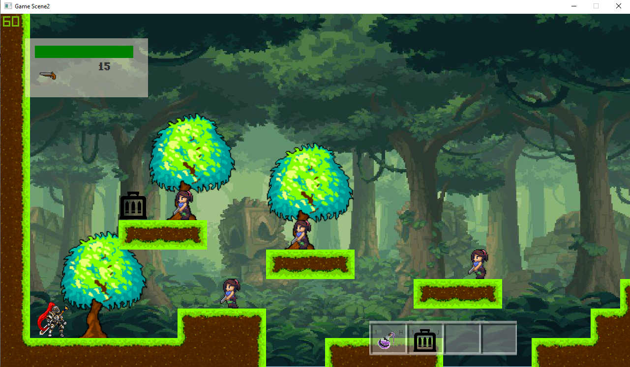

- you should avoid your character form enemy bullet. If bullet hit your main character, then your Hp will decrease.

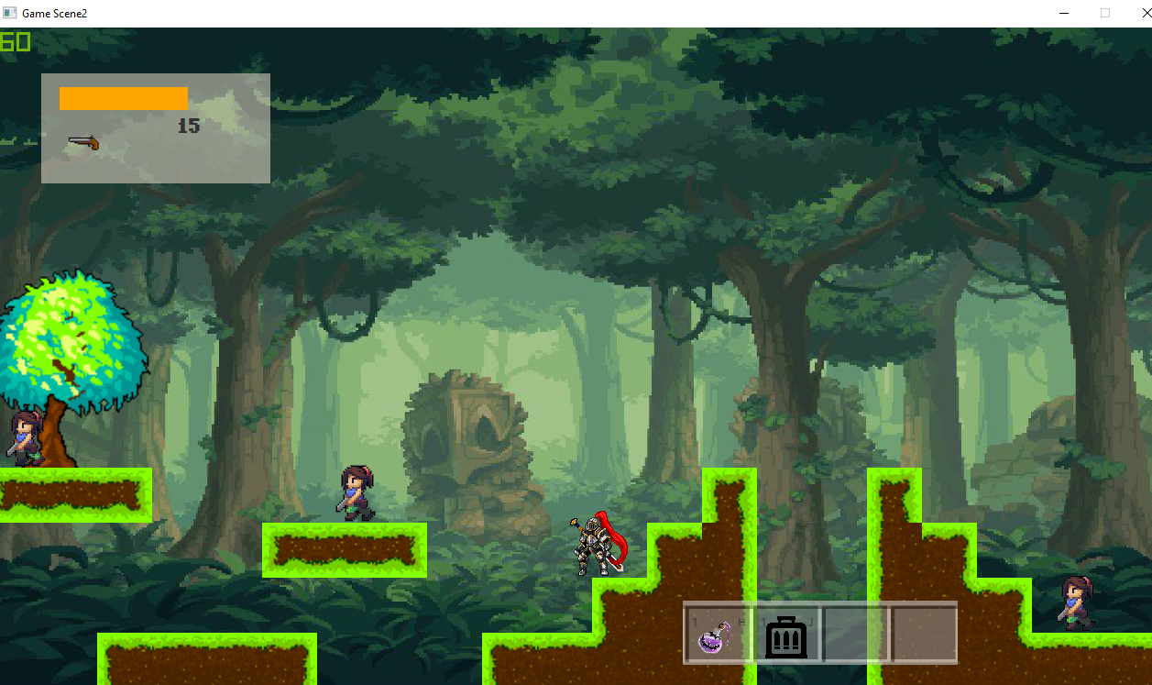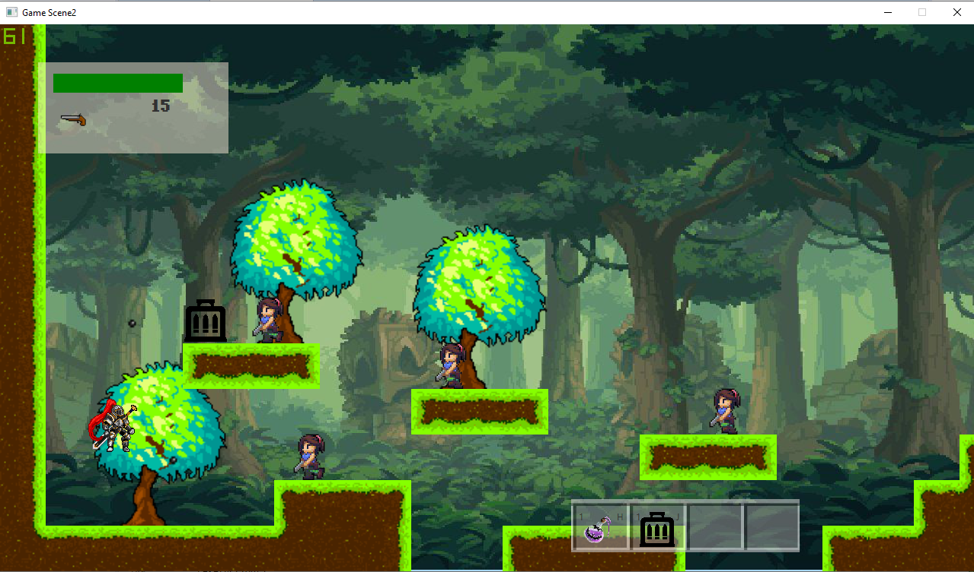

- use your weapon to attack the enemy. Specific weapon will deal different damage with enemy. In order to go to the next level, you must pass through the enemies in the map level.

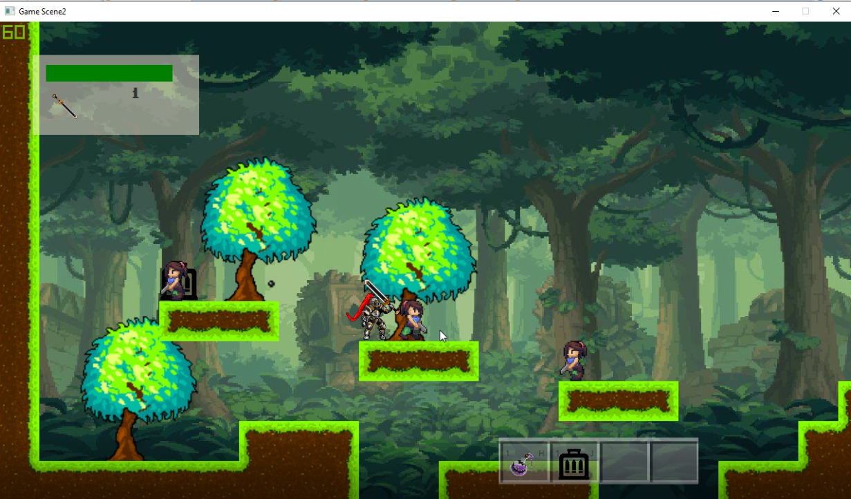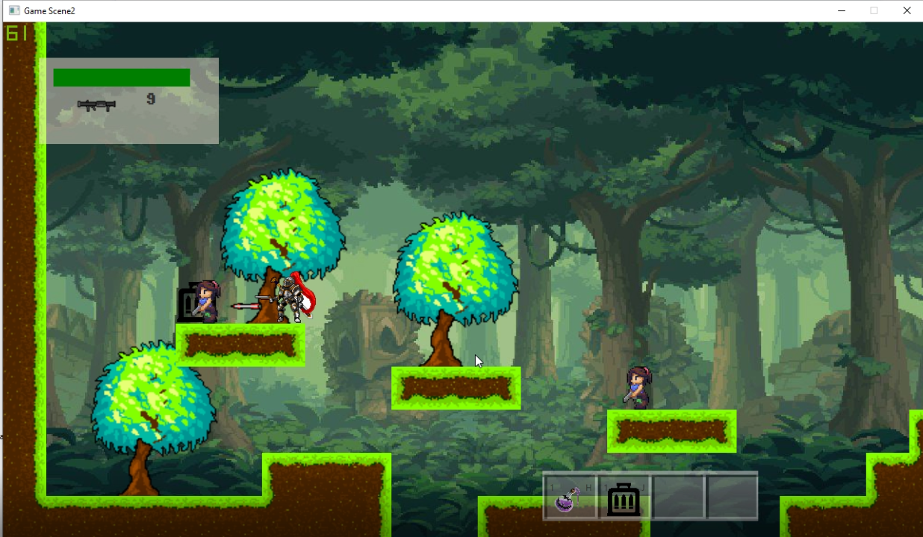

- move to the very right of the map to find a portal. You can go to the next level by pressing ENTER key.

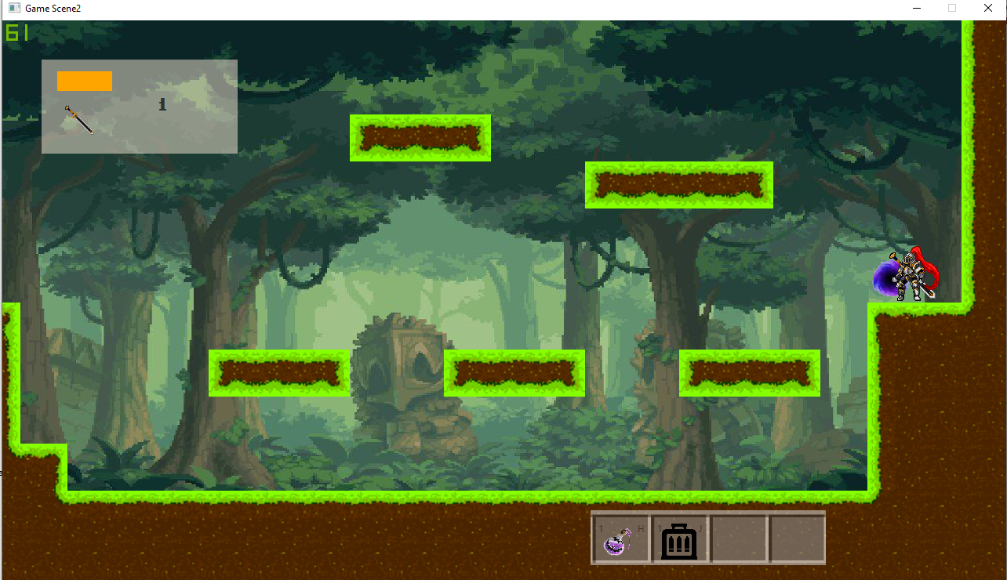

- your game will over if you fall off the map or HP below zero.

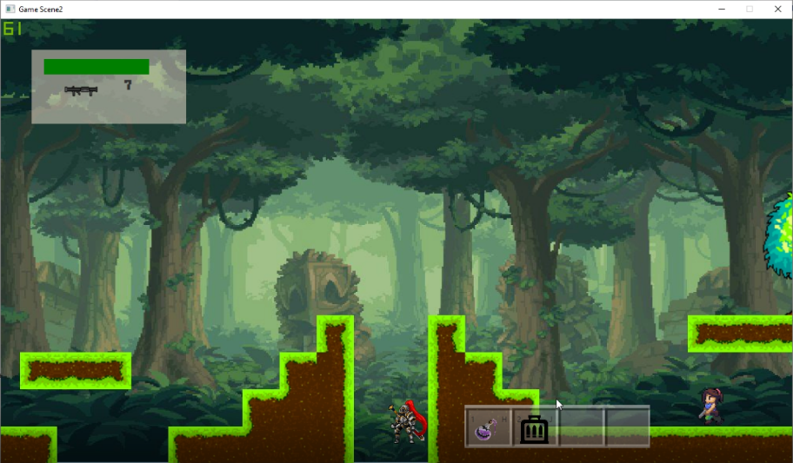

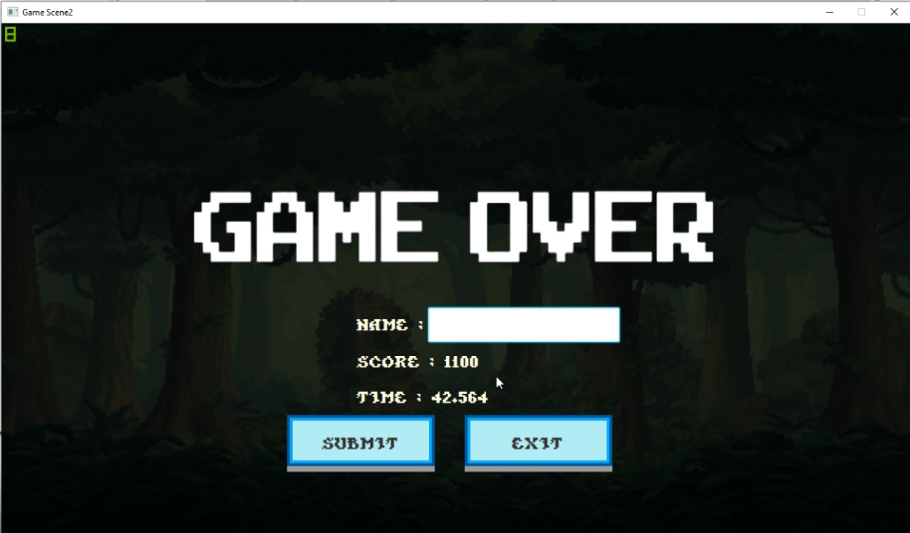

- You must kill the final boss to win the game. In the boss stage the boss will attack you with a bomb. While the boss is attacking, there will have boss pensioner spawn at the floor and try to attack your main character.

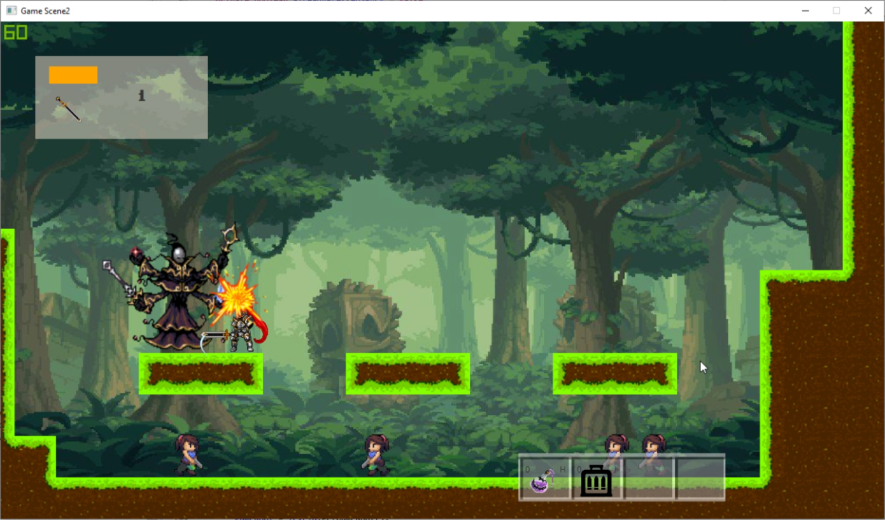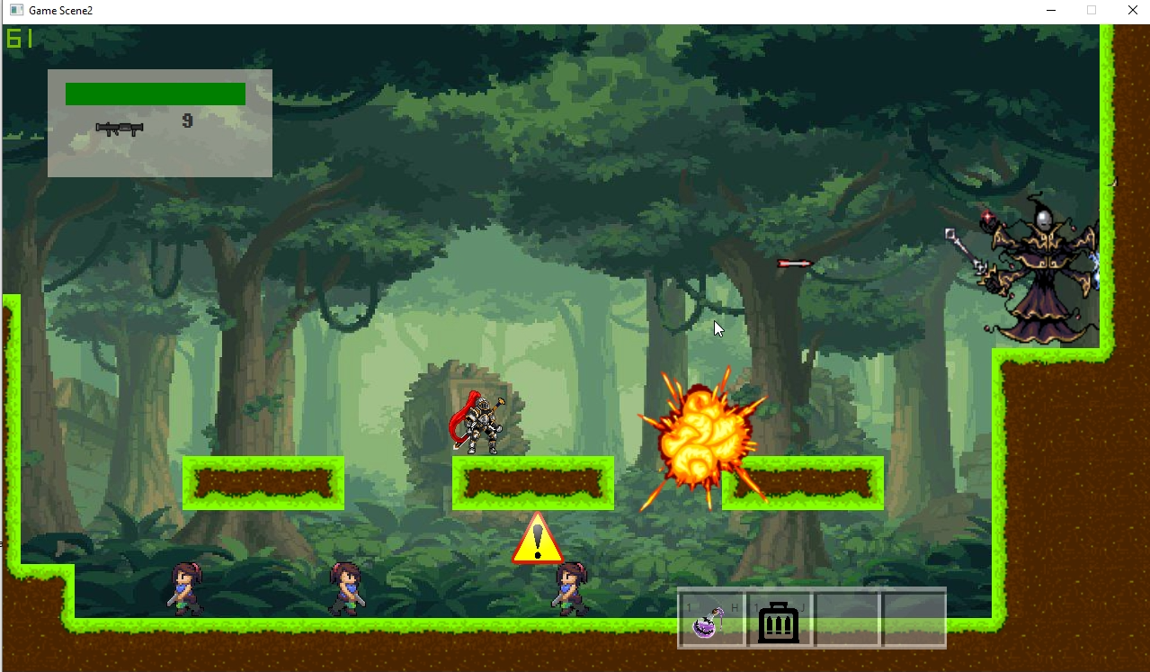

- If you kill the boss, you will win the game. The score and used time will show at the end. You can submit your name or not. then, you will return to main menu.

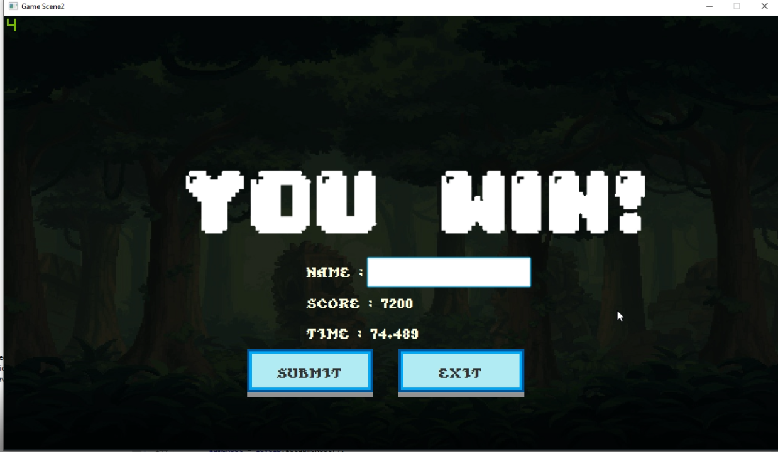

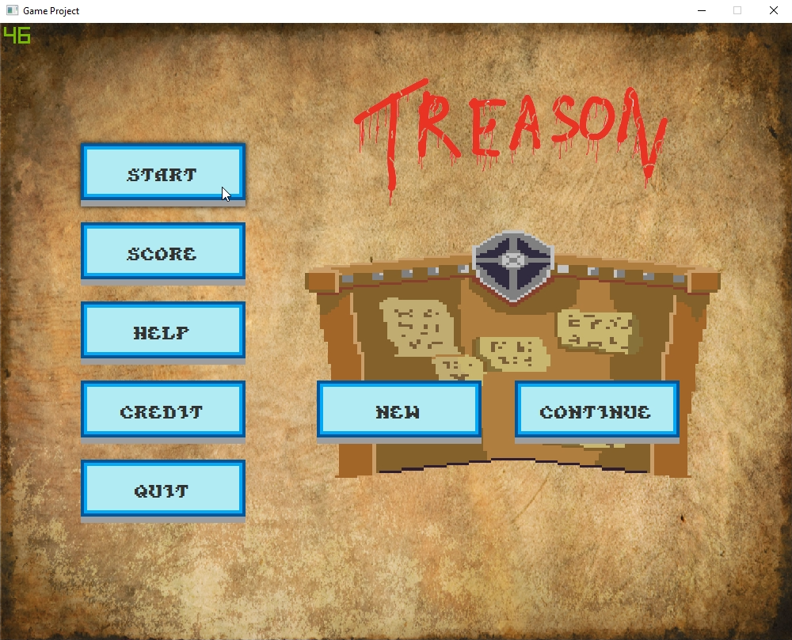- The main menu pane will show the 5 buttons. You can start the game by click start new game or you can continue your game if you exit your game and still didn’t close the window yet.

- score button will show 10 highest score that have been submitted. Help button will give you some help. Credit button will show creator picture. Quit button will close the game window.

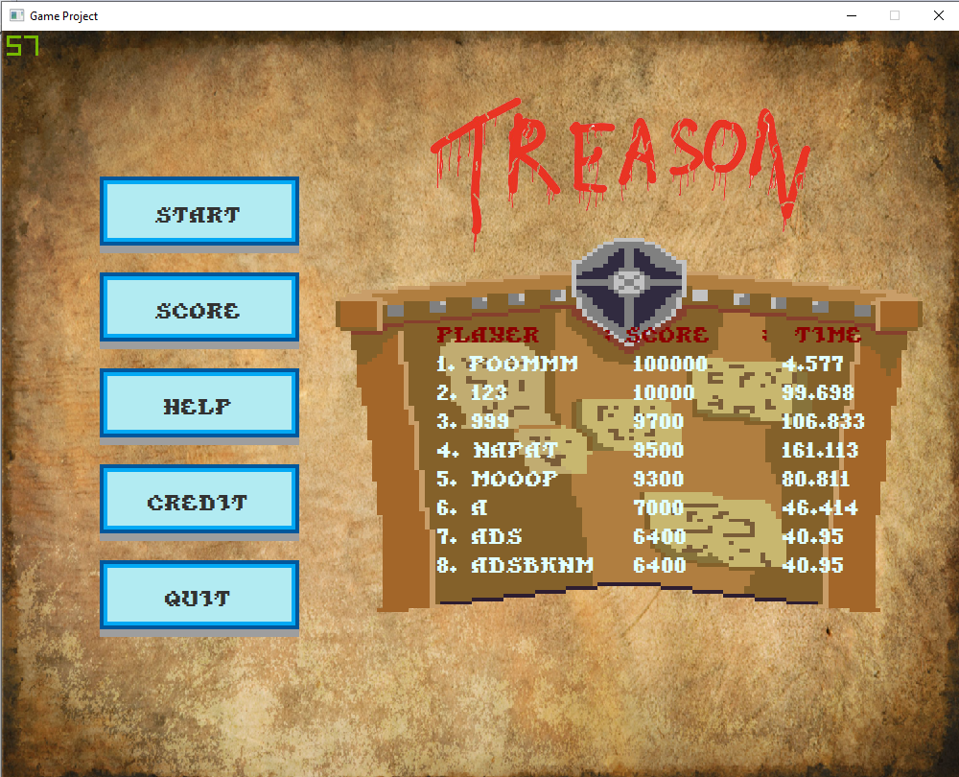

# Class Diagram

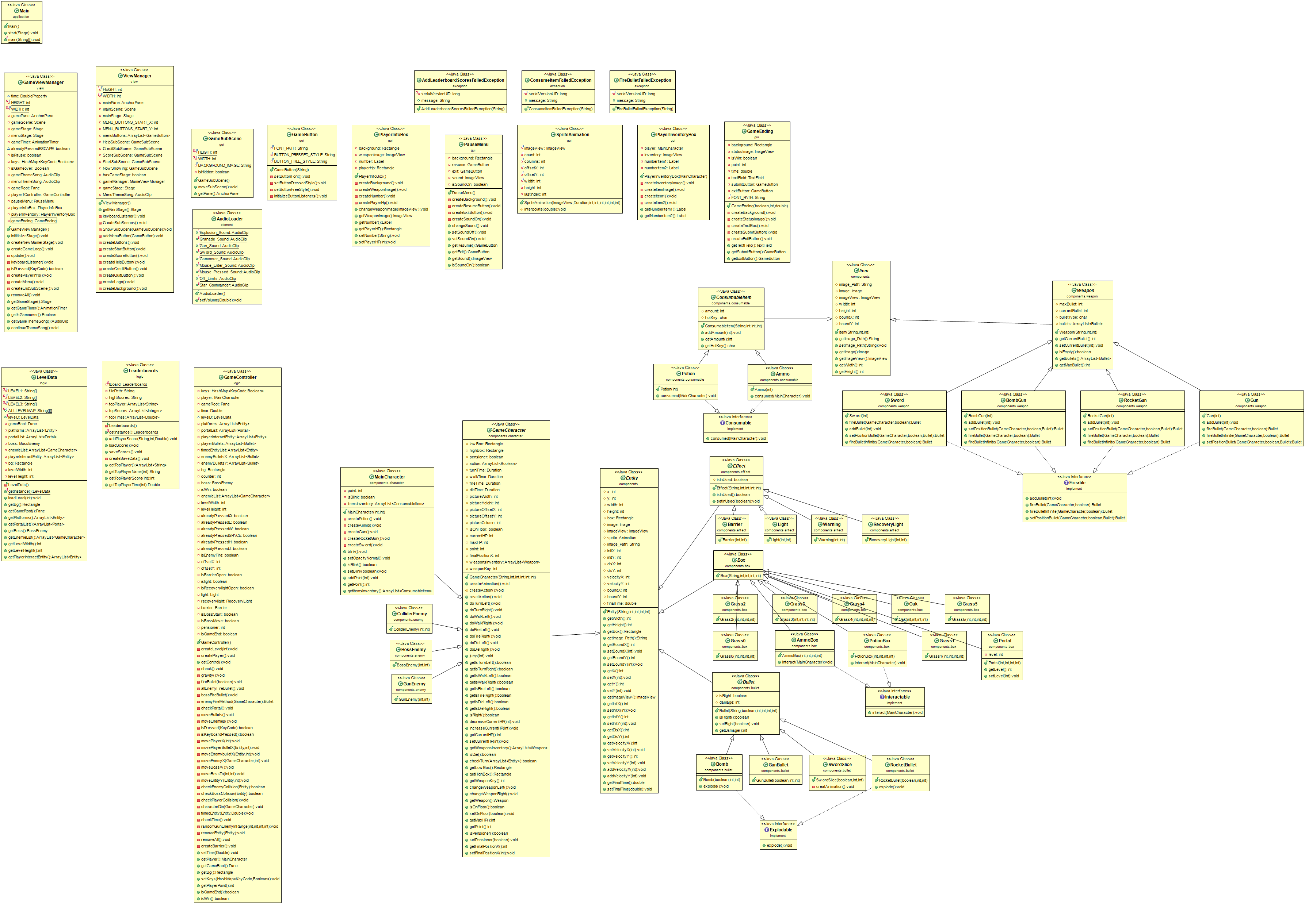

# 1 package main

1.1 Class Mainextends Application

This class is the main application interface.

### 1.1.1 Methods

|  |  |
| --- | --- |
| +void start(Stage primaryStage) | Starting the main application, put in Interfaces element. |
| +void main(String[] args) | Main application |

# 2 package element

## 2.1 Class AudioLoader

### 2.1.1 Fields

|  |  |
| --- | --- |
| + static AudioClip Explosion_Sound | Explosion sound |
| + static AudioClip Granade_Sound | Granade sound |
| + static AudioClip Gun_Sound | Gun sound |
| + static AudioClip Sword_Sound | Sword sound |
| + static AudioClip Gameover_Sound | Game over sound |
| + static AudioClip Mouse_Enter_Sound | Mouse enter sound |
| + static AudioClip Mouse_Pressed_Sound | Mouse pressed sound |
| + static AudioClip Off_Limits | BGM |
| + static AudioClip Star_Commander | BGM |

### 2.1.2 Methods

|  |  |
| --- | --- |
| + static void setVolume(Double volume) | Set the volume of every AudioClip |

# 3 package exception

## **3.1 Class AddLeaderboardScoresFailed** extends Exception

### 3.1.1 Fields

|  |  |
| --- | --- |
| - static final long serialVersionUID | Set to 1L |
| + String message | Error message |

### 3.1.2 Constructor

|  |  |
| --- | --- |
| + AddLeaderboardScoresFailedException(String message) | Initialize all remaining fields |

## 3.2 Class ConsumeItemFailedException extends Exception

### 3.2.1 Fields

|  |  |
| --- | --- |
| - static final long serialVersionUID | Set to 1L |
| + String message | Error message |

### 3.2.2 Constructor

|  |  |
| --- | --- |
| + ConsumeItemFailedException(String message) | Initialize all remaining fields |

## 3.3 Class FireBulletFailedException extends Exception

### 3.3.1 Fields

|  |  |
| --- | --- |
| - static final long serialVersionUID | Set to 1L |
| + String message | Error message |

### 3.3.2 Constructor

|  |  |
| --- | --- |
| + FireBulletFailedException(String message) | Initialize all remaining fields |

# 4 package gui

## 4.1 Class Gamebutton extends Button

### 4.1.1 Fields

|  |  |
| --- | --- |
| - final String FONT_PATH | Path of font |
| - final String BUTTON_PRESSED_STYLE | Style of button when pressed |
| - final String BUTTON_FREE_STYLE | Style of button when not pressed |

### 4.1.2 Constructor

|  |  |
| --- | --- |
| + GameButton(String text) | Initialize all remaining fields |

### 4.1.1 Methods

|  |  |
| --- | --- |
| - void setButtonFont() | Set the font of the button |
| - void setButtonPressedStyle() | Set the style of the button when pressed |
| - void setButtonFreeStyle() | Set the style of the button when not pressed |
| - void initializeButtonListerners() | Initialize all EventHandler |

## 4.2 Class GameEndingScene extends AnchorPane

### 4.2.1 Fields

|  |  |
| --- | --- |
| - Rectangle background | Background |
| - ImageView LogoImage | Status image |
| - Boolean isWin | Status |
| - int point | Point gained |
| - double time | Time spend |
| - TextField textField | Text field |
| - GameButton submitButton | Submit button |
| - GameButton exitButton | Exit button |

### 4.2.2 Constructor

|  |  |
| --- | --- |
| + GameEndingScene(Boolean isWin, int point, double time) | Initialize all remaining fields |

### 4.2.1 Methods

|  |  |
| --- | --- |
| - void createBackground() | Create background |
| - void createStatusImage() | Create Status image  if win show win picture  else show game over |
| - void createTextBox() | Create 3 textboxes (Name,Score,Time) |
| - void createSubmitButton() | Create submit button |
| - void createExitButton() | Create exit button |
| Getter of fields |  |

## 4.3 Class GameSubScene extends SubScene

### 4.3.1 Fields

|  |  |
| --- | --- |
| - static final int HEIGHT | Set to 400 |
| - static final int WIDTH | Set to 600 |
| - final String FONT_PATH | Path of font |
| - final String BACKGROUND_IMAGE | Background image path |
| - Boolean isHidden | Hidden status |

### 4.3.2 Constructor

|  |  |
| --- | --- |
| + GameSubScene() | Initialize all remaining fields  Set hidden status to true |

### 4.3.1 Methods

|  |  |
| --- | --- |
| - void moveSubScene () | Show the sub scene if hidden status is false and vice versa |
| - AnchorPane getPane() | Return pane |

## 4.4 Class PauseMenu extends AnchorPane

### 4.4.1 Fields

|  |  |
| --- | --- |
| - Rectangle background | Background |
| - GameButton resume | Resume button |
| - GameButton restart | Restart button |
| - GameButton exit | Exit button |
| - ImageView sound | Sound icon |
| - Boolean isSoundON | Sound status |

### 4.4.2 Constructor

|  |  |
| --- | --- |
| + PauseMenu | Initialize all remaining fields |

### 4.4.3 Methods

|  |  |
| --- | --- |
| - void createBackground() | Create background |
| - void createResumeButton() | Create resume button |
| - void createRestartButton() | Create restart button |
| - void createExitButton() | Create exit button |
| - void createSoundOn() | Create sound button |
| + void changeSound() | Change the sound status |
| + void setSoundOff() | Set sound status to false |
| + void setSoundOn() | Set sound status to true |
| Getter of fields |  |

## 4.5 Class PlayerInfoBox extends AnchorPane

### 4.5.1 Fields

|  |  |
| --- | --- |
| - Rectangle background | Background |
| - ImageView weaponImage | Weapon images |
| - Label number | number |
| - Rectangle playerHp | Hp of player |

### 4.5.2 Constructor

|  |  |
| --- | --- |
| + PlayerInfoBox | Initialize all remaining fields |

### 4.5.3 Methods

|  |  |
| --- | --- |
| - void createBackground() | Create background |
| - void createWeaponImage() | Create weapon image |
| - void createNumber() | Create number |
| - void createPlayerHp | Create player Hp |
| + void changeWeaponImage(ImageView imageView) | Change weapon image |
| Getter/Setter of fields |  |

## 4.6 Class PlayerInventoryBox extends AnchorPane

### 4.6.1 Fields

|  |  |
| --- | --- |
| - MainCharacter player | Player |
| - ImageView inventory | Inventory image |
| - Label numberItem1 | number |
| - Label numberItem2 | number |

### 4.6.2 Constructor

|  |  |
| --- | --- |
| + PlayerInventoryBox(MainCharacter player) | Initialize all remaining fields |

### 4.6.3 Methods

|  |  |
| --- | --- |
| - void createInventoryImage() | Create inventory image |
| - void createItemImage() | Create item image |
| - void createItem1() | Create numberItem1 |
| - void createItem2() | Create numberItem2 |
| Getter of fields |  |

## 4.7 Class SpriteAnimation extends Transition

### 4.7.1 Fields

|  |  |
| --- | --- |
| - final ImageView imageView | ImageView |
| - final int count | Count |
| - final int colums | Colums |
| - final int offsetX | X-offset |
| - final int offsetY | Y-offset |
| - final int width | width |
| - final int height | height |
| - final int lastIndex | Last index |

### 4.7.2 Constructor

|  |  |
| --- | --- |
| + SpriteAnimation(ImageView imageView, Duration duration, int count, int colums, int offsetX, int offset, int width, int height) | Initialize all remaining fields |

### 4.7.3 Methods

|  |  |
| --- | --- |
| # void interpolate(double k) | Interpolate sprites |

# 5 package implement

## 5.1 Interface Consumable

### 5.1.1 Methods

|  |  |
| --- | --- |
| + abstract void consumed(MainCharacter player) throws ConsumeItemFailedException | Check consuming item |

## 5.2 Interface Explodable

### 5.2.1 Methods

|  |  |
| --- | --- |
| + abstract void explode() | explode |

## 5.3 Interface Fireable

### 5.3.1 Methods

|  |  |
| --- | --- |
| + abstract void addBullet(int count) | Add bullet |
| + abstract Bullet fireBullet(GameCharacter character, Boolean isRight) throws FireBulletFailedException | Fire bullet |
| + abstract Bullet fireBulletIninite(GameCharacter character, Boolean isRight) | Fire without consuming bullet |
| + abstract Bullet setPositionBullet(GameCharacter character, Boolean isRight, Bullet bullet) | Bullet position |

## 5.4 Interface Interactable

### 5.4.1 Methods

|  |  |
| --- | --- |
| + abstract void interact(MainCharacter player) | Interact |

# 6 package components

## 6.1 Abstract Class Entity

### 6.1.1 Fields

|  |  |
| --- | --- |
| # int x | X position |
| # int y | Y position |
| # int width | Width |
| # int height | Height |
| # Rectangle box | Box |
| # Image image | Image |
| # ImageView imageView | ImageView |
| # Animation sprite | Sprite |
| # String image_Path | Path of image |
| # int initX | Initial x |
| # int initY | Initial y |
| # int disX | X distant entity can move |
| # int disY | Y distant entity can move |
| # int velocityX | X velocity |
| # int velocityY | Y velocity |
| # int boundX | X bound of image |
| # int boundY | Y bound of image |
| # int addOnX | Move entity in x direction on top |
| # int addOnY | Move entity in y direction on top |
| # double finalTime | Time before entity get deleted |

### 6.1.2 Constructor

|  |  |
| --- | --- |
| # Entity(String image Path,int initX,int initY,int width,int height) | Initialize all remaining fields |

### 6.1.3 Methods

|  |  |
| --- | --- |
| Getter/Setter of fields |  |

## 6.2 Abstract Class Item

### 6.2.1 Fields

|  |  |
| --- | --- |
| # String image_Path | Path of image |
| # Image image | Image |
| # ImageView imageView | ImageView |
| # int width | Width |
| # int height | Height |
| # int boundX | X bound of image |
| # int boundY | Y bound of image |

### 6.2.2 Constructor

|  |  |
| --- | --- |
| + Item(String image_Path, int width, int height) | Initialize all remaining fields |

### 6.2.3 Methods

|  |  |
| --- | --- |
| Getter/Setter of fields |  |

## 6.3 Package box

### 6.3.1 Abstract Class Box extends Entity

#### 6.3.1.1 Constructor

|  |  |
| --- | --- |
| + Box(String image_path, int initX, int initY, int width, int height) | Initialize all remaining fields |

### 6.3.2 Class AmmoBox extends Box implements Interactable

#### 6.3.2.1 Constructor

|  |  |
| --- | --- |
| + AmmoBox(int initX, int initY, int width, int height) | lnitialize all remaining fields |

#### 6.3.2.2 Methods

|  |  |
| --- | --- |
| + void interact(MainCharacter player) | Add ammo box to player inventory when interacted |

### 6.3.3 Class Grass0 extends Box

#### 6.3.3.1 Constructor

|  |  |
| --- | --- |
| + Grass0(int initX, int initY, int width, int height) | Initialize all remaining fields |

### 6.3.4 Class Grass1 extends Box

#### 6.3.4.1 Constructor

|  |  |
| --- | --- |
| + Grass1(int initX, int initY, int width, int height) | Initialize all remaining fields |

### 6.3.5 Class Grass2 extends Box

#### 6.3.5.1 Constructor

|  |  |
| --- | --- |
| + Grass2(int initX, int initY, int width, int height) | Initialize all remaining fields |

### 6.3.6 Class Grass3 extends Box

#### 6.3.6.1 Constructor

|  |  |
| --- | --- |
| + Grass3(int initX, int initY, int width, int height) | Initialize all remaining fields |

### 6.3.7Class Grass4 extends Box

#### 6.3.7.1 Constructor

|  |  |
| --- | --- |
| + Grass4(int initX, int initY, int width, int height) | Initialize all remaining fields |

### 6.3.8 Class Grass5 extends Box

#### 6.3.8.1 Constructor

|  |  |
| --- | --- |
| + Grass5(int initX, int initY, int width, int height) | Initialize all remaining fields |

### 6.3.9 Class Oak extends Box

#### 6.3.9.1 Constructor

|  |  |
| --- | --- |
| + Oak(int initX, int initY, int width, int height) | Initialize all remaining fields |

### 6.3.10 Class Portal extends Box

#### 6.3.10.1 Fields

|  |  |
| --- | --- |
| - int level | Game level |

#### 6.3.10.2 Constructor

|  |  |
| --- | --- |
| + Portal(int initX, int initY, int width, int height) | Initialize all remaining fields |

#### 6.3.10.3 Methods

|  |  |
| --- | --- |
| Getter/Setter of fields |  |

### 6.3.11 Class PotionBox extends Box implements Interactable

#### 6.4.11.1 Constructor

|  |  |
| --- | --- |
| + PotionBox(int initX, int initY, int width, int height) | Initialize all remaining fields |

#### 6.3.11.1 Methods

|  |  |
| --- | --- |
| + void interact(MainCharacter player) | Add potion to player inventory when interacted |

## 6.4 Package bullet

### 6.4.1 Class Bomb extends Bullet implements Exploadble

#### 6.4.1.1 Constructor

|  |  |
| --- | --- |
| + Bomb(boolean isRight, int initX, int initY) | Initialize all remaining fields |

#### 6.4.1.2 Methods

|  |  |
| --- | --- |
| + void explode() | Play explosion sound  Run explosion animation |

### 6.4.2 Abstract Class Bullet extends Entity

#### 6.4.2.1 Fields

|  |  |
| --- | --- |
| # boolean isRignt | Boolean |
| # int damage | Damage |

#### 6.4.2.2 Constructor

|  |  |
| --- | --- |
| + Bullet(String image_Path, boolean isRight, int initX, int initY, int width, int height) | Initialize all remaining fields |

#### 6.4.2.3 Methods

|  |  |
| --- | --- |
| Getter/Setter of fields |  |

### 6.4.3 Class GunBullet extends Bullet

#### 6.4.3.1 Constructor

|  |  |
| --- | --- |
| + GunBullet(boolean isRight, int initX, int initY) | Initialize all remaining fields |

### 6.4.4 Class RocketBullet extends Bullet implements Exploadble

#### 6.4.4.1 Constructor

|  |  |
| --- | --- |
| + RocketBullet(boolean isRight, int initX, int initY) | Initialize all remaining fields |

#### 6.4.4.2 Methods

|  |  |
| --- | --- |
| + void explode() | Play explosion sound  Run explosion animation |

### 6.4.5 Class SwordSlice extends Bullet

#### 6.4.5.1 Constructor

|  |  |
| --- | --- |
| + SwordSlice(boolean isRight, int initX, int initY) | Initialize all remaining fields |

#### 6.4.5.2 Methods

|  |  |
| --- | --- |
| + void createAnimation() | Create sword animation |

## 6.5 Package character

### 6.5.1 Abstract Class GameCharacter extends Entity

#### 6.5.1.1 Fields

|  |  |
| --- | --- |
| # Rectangle lowBox | A box below the character feet |
| # Rectangle highBox | A box above the character head |
| # ArrayList<Boolean> | Arraylist of all action |
| # boolean pensioner | Counter for character pensioner |
| # Duration turnTime | Turn duration time |
| # Duration walkTime | Walk duration time |
| # Duration fireTime | Fire duration time |
| # int pictureWidth | Image width |
| # int pictureHeight | Image height |
| # int pictureOffsetX | Image start point in x axis |
| # int pictureOffsetY | Image start point in y axis |
| # int pictureColumn | Number of each image column in sprite |
| # boolean is OnFloor | Is character on floor |
| # int currentHP | Current Hp of character |
| # int maxHP | Max Hp of character |
| # int point | point |
| # int finalPositionX | Destination in x axis |
| # ArrayList<Weapon> weaponInventory | List of character’s weapons |
| # int weaponKey | Current weapon key |

#### 6.5.1.2 Constructor

|  |  |
| --- | --- |
| + GameCharacter(String image_Path, int initX, int initY, int width, int height, int currentHP) | Initialize all remaining fields |

#### 6.5.1.3 Methods

|  |  |
| --- | --- |
| + void createAnimation() | Create animation using sprite |
| # void createAnimation() | Initialize all action and add to arraylist |
| + void resetAction() | Reset all action Boolean to false |
| + void doTurnRight() | Play sprite animation and set boolean turn right to true |
| + void doTurnLeftt() | Play sprite animation and set boolean turn left to true |
| + void doWalkLeft() | Play sprite animation and set boolean walk right to true |
| + void doWalkRight() | Play sprite animation and set boolean walk left to true |
| + void doFireLeft() | Play sprite animation and set boolean fire right to true |
| + void doFireRight() | Play sprite animation and set boolean fire left to true |
| + void doDieLeft() | Play sprite animation and set boolean die right to true |
| + void doDieRight() | Play sprite animation and set boolean die left to true |
| + void jump() | Jump |
| + void decreaseCurrentHP(int damage) | Decrease character Hp |
| + void increaseCurrentHP(int heal) | Heal character |
| + boolean checkTurn(ArrayList<Entity> platforms) | Check if low box of character doesn’t collide with any platform box then return true.  Also check if high box collides with any platform then return true. Something else return false. |
| + void changeWeaponLeft() | Decrease weaponKey |
| + void changeWeaponRight() | Increase weaponKey |
| Getter/Setter of fields |  |

### 6.5.2 Class MainCharacter extends GameCharacter

#### 6.5.2.1 Fields

|  |  |
| --- | --- |
| - int point | Point |
| - boolean isBlink | Invincible state |
| # ArrayList<ConsumableItem> itemsInventory | Item inventory |

#### 6.5.2.2 Constructor

|  |  |
| --- | --- |
| + MainCharacter(int initX, int initY) | Initialize all remaining fields  Create potion, ammo, gun, rocket gun, sword |

#### 6.5.2.3 Methods

|  |  |
| --- | --- |
| - void createPotion() | Create potion and add to itemsInventory |
| - void createAmmo() | Create ammo and add to itemsInventory |
| - void createGun() | Create gun and add to weaponsInventory |
| - void createRocketGun() | Create rocket gun and add to weaponsInventory |
| - void createSword() | Create sword and add to weaponsInventory |
| + void blink() | Set opacity |
| + void setOpacityNormal() | Set opacity to 1 |
| Getter/Setter of fields |  |

## 6.6 Package consumable

### 6.6.1 Class Ammo extends ConsumableItem implements Consumable

#### 6.6.1.1 Constructor

|  |  |
| --- | --- |
| + Ammo(int amount) | Initialize all remaining fields  Set hotkey |

#### 6.6.1.2 Methods

|  |  |
| --- | --- |
| + void consumed() throws ConsumeItemFailedException | Decrease item when used  Add 10 bullet to the carried weapon  If item is 0 throw exception  If bullet is full throw exception |

### 6.6.2 Abstract Class ConsumableItem extends Item

#### 6.6.2.1 Fields

|  |  |
| --- | --- |
| # int amount | Amount |
| # char hotKey | Hotkey |

#### 6.6.2.2 Constructor

|  |  |
| --- | --- |
| + ConsumableItem(String image_Path, int width, int height, int amount) | Initialize all remaining fields |

#### 6.6.2.3 Methods

|  |  |
| --- | --- |
| + void addAmount(int amount) | Increase item |
| Getter of fields |  |

### 6.6.3 Class Potion extends ConsumableItem implements Consumable

#### 6.6.3.1 Constructor

|  |  |
| --- | --- |
| + Potion(int amount) | Initialize all remaining fields  Set hotkey |

#### 6.6.3.2 Methods

|  |  |
| --- | --- |
| + void consumed()throws ConsumeItemFailedException | Decrease item when used  Add 100 hp to game character  If item is 0 throw exception  If health is full throw exception |

## 6.7 Package effect

### 6.7.1 Class Barrier extends Effect

#### 6.7.1.1 Constructor

|  |  |
| --- | --- |
| + Barrier(int initX, initY) | Initialize all remaining fields  Play sprite |

### 6.7.2 Abstract Class Effect extends Entity

#### 6.7.2.1 Fields

|  |  |
| --- | --- |
| # boolean isInUsed | Status |

#### 6.7.2.2 Constructor

|  |  |
| --- | --- |
| + Effect(String image_Path, int initX, int initY, int width, int height, int amount) | Initialize all remaining fields  IsInUsed = true |

#### 6.7.2.3 Methods

|  |  |
| --- | --- |
| + void addAmount(int amount) | Increase item |
| Getter/Setter of fields |  |

### 6.7.3 Class Light extends Effect

#### 6.7.3.1 Constructor

|  |  |
| --- | --- |
| + Light(int initX, initY) | Initialize all remaining fields  Play sprite |

### 6.7.4 Class RecoveryLight extends Effect

#### 6.7.4.1 Constructor

|  |  |
| --- | --- |
| + recoveryLight(int initX, initY) | Initialize all remaining fields  Play sprite |

### 6.7.5 Class Warning extends Effect

#### 6.7.5.1 Constructor

|  |  |
| --- | --- |
| + Warning(int initX, initY) | Initialize all remaining fields |

## 6.8 Package enemy

### 6.8.1 Class BossEnemy extends GameCharacter

#### 6.8.1.1 Constructor

|  |  |
| --- | --- |
| + BossEnemy (int initX, initY) | Initialize all remaining fields  Create gun and add to inventory  Play sprite |

### 6.8.2 Class ColliderEnemy extends GameCharacter

#### 6.8.2.1 Constructor

|  |  |
| --- | --- |
| + BossEnemy (int initX, initY) | Initialize all remaining fields |

### 6.8.3 Class GunEnemy extends GameCharacter

#### 6.8.3.1 Constructor

|  |  |
| --- | --- |
| + GunEnemy (int initX, initY) | Initialize all remaining fields  Create gun and add to inventory |

## 6.9 Package weapon

### 6.9.1 Class BombGun extends Weapon implements Fireable

#### 6.9.1.1 Constructor

|  |  |
| --- | --- |
| + BombGun(int bullet) | Initialize all remaining fields  Set maximum bullet to 10  Add bullet |

#### 6.9.1.2 Methods

|  |  |
| --- | --- |
| + void addBullet(int count) | Increase bullet |
| + Bullet setPositionBullet(GameCharacter, character, boolean isRight, Bullet bullet) | Set bullet position |
| + Bullet fireBullet(GameCharacter, character, boolean isRight) throws FireBulletFailedException | Fire bullet  Throws exception if there is not any bullet left in this weapon |
| + Bullet fireBulletInfinite(GameCharacter, character, boolean isRight) | Fire bullet without using ammo |

### 6.9.2 Class Gun extends Weapon implements Fireable

#### 6.9.2.1 Constructor

|  |  |
| --- | --- |
| + Gun(int bullet) | Initialize all remaining fields  Set maximum bullet to 15  Add bullet |

#### 6.9.2.2 Methods

|  |  |
| --- | --- |
| + void addBullet(int count) | Increase bullet |
| + Bullet setPositionBullet(GameCharacter, character, boolean isRight, Bullet bullet) | Set bullet position |
| + Bullet fireBullet(GameCharacter, character, boolean isRight) throws FireBulletFailedException | Fire bullet  Throws exception if there is not any bullet left in this weapon |
| + Bullet fireBulletInfinite(GameCharacter, character, boolean isRight) | Fire bullet without using ammo |

### 6.9.3 Class RocketGun extends Weapon implements Fireable

#### 6.9.3.1 Constructor

|  |  |
| --- | --- |
| + RocketGun(int bullet) | Initialize all remaining fields  Set maximum bullet to 10  Add bullet |

#### 6.9.3.2 Methods

|  |  |
| --- | --- |
| + void addBullet(int count) | Increase bullet |
| + Bullet setPositionBullet(GameCharacter, character, boolean isRight, Bullet bullet) | Set bullet position |
| + Bullet fireBullet(GameCharacter, character, boolean isRight) throws FireBulletFailedException | Fire bullet  Throws exception if there is not any bullet left in this weapon |
| + Bullet fireBulletInfinite(GameCharacter, character, boolean isRight) | Fire bullet without using ammo |

### 6.9.4 Class Sword extends Weapon implements Fireable

#### 6.9.4.1 Constructor

|  |  |
| --- | --- |
| + Sword(int bullet) | Initialize all remaining fields  Set maximum bullet to 1  Add bullet |

#### 6.9.4.2 Methods

|  |  |
| --- | --- |
| + void addBullet(int count) | Increase bullet |
| + Bullet setPositionBullet(GameCharacter, character, boolean isRight, Bullet bullet) | Set bullet position |
| + Bullet fireBullet(GameCharacter, character, boolean isRight) throws FireBulletFailedException | Fire bullet  Throws exception if there is not any bullet left in this weapon |
| + Bullet fireBulletInfinite(GameCharacter, character, boolean isRight) | Fire bullet without using ammo |

### 6.9.5 Abstract Class Weapon extends Item

#### 6.9.5.1 Fields

|  |  |
| --- | --- |
| # int maxBullet | Maximum bullet |
| # int currentBullet | Current bullet |
| # char bulletType | Bullet type |
| # ArrayList<Bullet> bullets | ArrrayList for bullet |

#### 6.9.5.2 Constructor

|  |  |
| --- | --- |
| + Weapon(String image_Path, int width, int height, int amount) | Initialize all remaining fields |

#### 6.9.5.3 Methods

|  |  |
| --- | --- |
| Getter/Setter of fields |  |

# 7 package logic

## 7.1 Class LevelData

### 7.1.1 Fields

|  |  |
| --- | --- |
| - static final String[] LEVEL1 | Array of string represent game map for level 1 |
| - static final String[] LEVEL2 | Array of string represent game map for level 2 |
| - static final String[] LEVEL3 | Array of string represent game map for level 3 |
| - static final String[][] ALLLEVELMAP | Array of all array map |
| - static LevelData levelD | LevelData data |
| - Pane gameRoot | Game pane for component |
| - ArrayList<Entity> platforms | ArrayList of all game box object |
| - ArrayList<Portal> portalList | ArrayList of all portal object |
| - BossEnemy boss | Boss enemy |
| - ArrayList<GameCharacter> enemieList | ArrayList of all enemy object |
| - ArrayList<Entity> playerInteractEntity | ArrayList of all object that can interact with player |
| - Rectangle bg | background |
| - int levelWidth | Level width |
| - int levelHeight | Level height |

### 7.1.2 Constuctor

|  |  |
| --- | --- |
| + LevelData() | Initialize all field |

### 7.1.3 Methods

|  |  |
| --- | --- |
| + LevelData getInstance() | Initialize all data |
| + void loadLevel(int level) | turn all string data into object form specific level |
| Generate getter of all fields | Level height |

## 7.2 Class Leaderboards

### 7.2.1 Fields

|  |  |
| --- | --- |
| - static Leaderboards lBoard | leaderboard |
| - String filePath | Leaderboard data File path |
| - String highScores | File name |
| - ArrayList<String> topPlayer | Arraylist of 10 top player names |
| - ArrayList<Integer> topScores | Arraylist of 10 top player scores |
| - ArrayList<Double> topTimes | Arraylist of 10 top player time records |

### 7.2.2 Constuctor

|  |  |
| --- | --- |
| + Leaderboards() | Initialize all field |

### 7.2.3 Methods

|  |  |
| --- | --- |
| + Leaderboard getInstance() | Initialize all data |
| +void addPlayerScore(String name, int score, Double time) throws AddLeaderboardScoresFailedException | Add player name, score, time to data arraylist  Name must be 1-10 characters or number.  If name is more than 10 throw exception.  If name contains marks or spaces throw exception.  If name is the same with old one throw exception |
| + void loadScore() | Load data |
| + void saveScores() | Save data |
| - void createSaveData() | Create save data incase it doesn’t have old data |
| Generate getter of all fields |  |

## 7.3 Class GameController

### 7.3.1 Fields

|  |  |
| --- | --- |
| - HashMap<KeyCode, Boolean> keys | HashMap of boolean keycode that pressed |
| - MainCharacter player | Main character |
| - Pane gameRoot | Game pane for component |
| - Double time | time |
| - LevelData levelD | map from LevelData |
| - ArrayList<Entity> platforms | Arraylist of box |
| - ArrayList<Portal> portalList | Arraylist of portal |
| - ArrayList<Entity> playerInteractEntity | Arraylist of entity that can interact with main character |
| - ArrayList<Bullet> playerBullets | Arraylist of bullet that fired from main character |
| - ArrayList<Entity> timedEntityList | Arraylist of entity that has been timed to remove |
| - ArrayList<Bullet> enemyBulletsX | Arraylist of bullet that fired from enemy character |
| - ArrayList<Bullet> enemyBulletsY | Arraylist of bullet that fired from enemy character |
| - Rectangle bg | background |
| - Boolean isWin | Check that is player win the game |
| - int counter | Loop counter |
| - BossEnemy boss | Boss character |
| - ArrayList<GameCharacter> enemieList | Arraylist of enemy character |
| - int levelWidth | Level map width |
| - int levelHeight | Level map height |
| - boolean alreadyPressedQ | Check that is player pressed already pressed Q |
| - boolean alreadyPressedE | Check that is player pressed already pressed E |
| - boolean alreadyPressedW | Check that is player pressed already pressed W |
| - boolean alreadyPressedSPACE | Check that is player pressed already pressed Spacebar |
| - boolean alreadyPressedH | Check that is player pressed already pressed H |
| - boolean alreadyPressedJ | Check that is player pressed already pressed J |
| - boolean isEnemyFire | Check that is enemy already fire bullet |
| - int offsetX | Player position in X axis |
| - int offsetY | Player position in Y axis |
| - boolean isBarrierOpen | Check that is game character open barrier |
| - boolean islight | Check that is game character open light |
| - boolean isRecoverylightOpen | Check that is game character open recoverylight |
| - Light light | light |
| - RecoveryLight recoveryLight | recoverylight |
| - Barrier barrier | barrier |
| - boolean isBossStart | Check that is boss start |
| - boolean isBossMove | Check that is boss move |
| - int pensioner | Number of boss pensioner |
| - boolean isGameEnd | Check that is the game end |

### 7.3.2 Constuctor

|  |  |
| --- | --- |
| + GameController() | Initialize all field |

### 7.3.3 Methods

|  |  |
| --- | --- |
| - void createLevel(int level) | Load map from level data |
| + void getControl() | Call all the movement method and keyboard handler |
| - void createPlayer() | Create main character |
| - void check() | Check all the check collision method |
| - void gravity() | Move some item in y axis like gravity |
| - void fireBullet(boolean) | Call the weapon fire method to fire bullet from main character |
| - void allEnemyFireBullet() | fire bullet from all enemy character if game character enters near enemy |
| - void bossFireBullet() | fire bullet from boss if boss mode start is start |
| - Bullet enemyFireMethod(GameCharacter enemy) | Call the weapon fire bullet method for specific enemy |
| - void checkPortal() | Check if main character collides with portal |
| - void moveBullets() | Call movePlayerBullet if the bullet is in playerBullets. Call moveEntityX if the bullet is in EnemyBulletsX. |
| - void moveEnemies() | Call moveEnemyX for all the enemy in enemy arraylist |
| - boolean isPressed(KeyCode keycode) | Return true if specific keycode is pressed |
| - boolean isKeyboardPressed() | Return false if all the keycode is not pressed.  Return true if has one keycode pressed. |
| - void movePlayerX(int value) | Move player in right if value is positive.  Move player to left if value is negative. |
| - void movePlayerBulletX(Entity item, int value) | Move all bullet in a fired direction (if fired right move right, if fired left move left) with specific velocity value  If enemy bullet collide with main character then decrease main character health.if enemy bullet collide with platform then remove.  If the bullet can explode then explode the bullet when hit something. |
| - void moveEnemybulletX(Entity item, int value) | Move all bullet in a fired direction (if fired right move right, if fired left move left) with specific velocity value.  If enemy bullet collide with main character then decrease main character health.if enemy bullet collide with platform then remove.  If the bullet can explode then explode the bullet when hit something. |
| - void moveEnemyX(GameCharacter enemy, int value) | Move specific enemy in a specific velocity value. |
| - void moveBossX() | move boss to specific location if hit the ground or arrive at the final position stop boss moving |
| - void moveBossTo(int, int) | Jump the boss and set the final position |
| - void moveEntityY(Entity entity, int value) | Move specific entity with specific velocity value |
| - boolean checkEnemyCollision(Entity entity) | Check is enemy collided with specific entity |
| - boolean checkBossCollision(Entity entity) | Check is boss collided with specific entity |
| - void checkPlayerCollision() | Check for all entity in playerInteractEntity |
| - void characterDie(GameCharacter gameCharacter) | Make a character die .then, remove it. |
| - void timedEntity(Entity entity, Double duration) | Timed the entity with a specific duration |
| - void checkTime() | Check all entity in timed list to remove it |
| - void randomGunEnemyInRange(int X1, int X2, int Y1, int Y2) | Spawn enemy in range of specific location |
| - void removeEntity(Entity entity) | Remove specific entity from game root |
| - void checkBossCollision(Entity entity) | Check that is boss collide with main character bullet |
| - void removeAll() | Remove all field |
| - void createBarrier() | Create barrier around main character |
| Generate getter of all fields |  |

# 8 package view

## 8.1 Class ViewManager

### 8.1.1 Fields

|  |  |
| --- | --- |
| - static final int HEIGHT | Height of main scene |
| - static final int WIDTH | Width of main scene |
| - AnchorPane mainPane | Main pane |
| - Scene mainScene | Main scene |
| - int MENU_BUTTONS_START_X | Layout of first button in x axis |
| - int MENU_BUTTONS_START_Y | Layout of first button in y axis |
| - GameSubScene HelpSubScene | Help Subscene show help infomation |
| - GameSubScene CreditSubScene | credit Subscene show creator name |
| - GameSubScene ScoreSubScene | score Subscene show 10 highest score player |
| - GameSubScene StartSubScene | start Subscene show start menu |
| - GameSubScene NowShowing | Now showing Subscene |
| - boolean hasGameStage | Check that player already start the game |
| - GameViewManager gameManager | Main gamemanager |
| - Stage gameStage | Game stage |
| - AudioClip MenuThemeSong | Game theme song (starcommander) |

### 8.1.2 Constructor

|  |  |
| --- | --- |
| + ViewManager() | Initialize all remaining fields |

### 8.1.3 Methods

|  |  |
| --- | --- |
| +stage getMainStage() | Return mainStage |
| - void keyboardListener() | Initialize keyboard listener |
| - void CreateSubScenes() | Create all subscene field |
| - void ShowSubScene(GameSubScene gameSubscene) | Show new subscene if there are other one that already show hide it before show the new one. |
| - void addMenuButton(GameButton button) | Add all button to menuButtons arraylist |
| - void createButtons() | Call all create button method |
| - void createStartButton() | Create start button |
| - void createScoreButton() | Create score button |
| - void createHelpButton() | Create help button |
| - void createCreditButton() | Create credit button |
| - void createQuitButton() | Create quit button |
| - void createLogo() | Create logo image |
| - void createBackground() | Create background image |

## 8.2 Class GameViewManager

### 8.2.1 Fields

|  |  |
| --- | --- |
| - long startTime | Time when start the animation timer loop |
| - DoubleProperty time | Time from animation timer loop |
| - static final int HEIGHT | Height of scene |
| - static final int WIDTH | Width of scene |
| - AnchorPane gamePane | Game pane |
| - Scene gameScene | Game scene |
| - Stage gameStage | Game stage |
| - Stage menuStage | Start menu stage |
| - AnimationTimer gameTimer | Game timer |
| - boolean alreadyPressedESCAPE | Check that is keyboard pressed escape button |
| - boolean isPause | Check that is game timer stop |
| - HashMap<KeyCode, Boolean> keys | Hash map of keycode from keyboard |
| - Boolean isGameover | Check that is Game end |
| - AudioClip gameThemeSong | Game theme song |
| - AudioClip menuThemeSong | start menu theme song |
| - Pane gameRoot | Game pane for component |
| - GameController player1Controller | Game controller |
| - PauseMenu pauseMenu | Pause menu pane |
| - PlayerInfoBox playerInfoBox | Player info pane |
| - PlayerInventoryBox playerInventory | Player inventory pane |
| - GameEndingScene gameEndingScene | Game ending pane |

### 8.2.2 Constructor

|  |  |
| --- | --- |
| + GameViewManager() | Call inititializeStage() |

### 8.2.3 Methods

|  |  |
| --- | --- |
| + void createNewGame(Stage) | Show game stage and hide start menu stage |
| + void createGameLoop() | Start the animation timer loop |
| - void update() | Update all the field |
| - void keyboardListener() | Keyboard handler |
| - Boolean isPressed(KeyCode keycode) | Return true if keycode is pressed  Return false if keycode isn’t pressed |
| - void createPlayerInfo() | Create player information Box and player inventory |
| - void createMenu() | Create game pauseMenu |
| - void createEndSubScene() | Create ending pane |
| + void removeAll() | Clear all field |
| + void continueThemeSong() | If sound in pauseMenu is close set game theme song stop. If sound is on set play game theme song. |
| Generate getter of all fields |  |